Lab – 5 Report

Submitted by Saikiran Pasala (16154892)

* Worked on the Got2Run game
* Modified the code in such a way that the Sensor tag is connected to the game and used it as accelerometer.

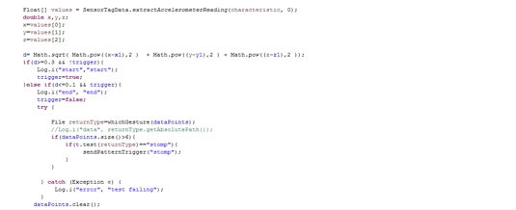

* And used a distance vector formula here and used a broadcaster service to broadcast the accelerometer data.
* 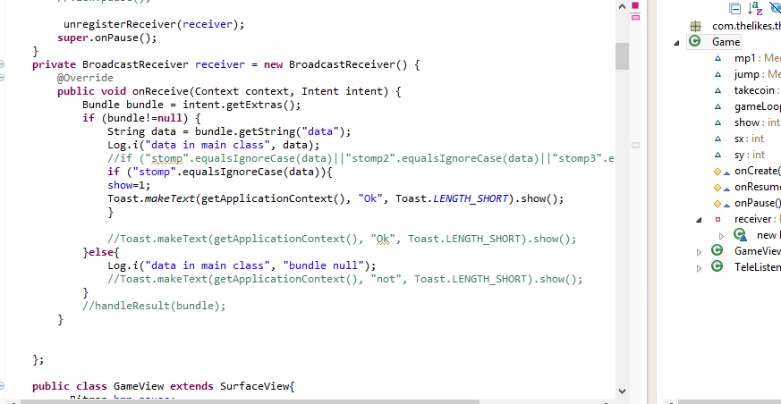

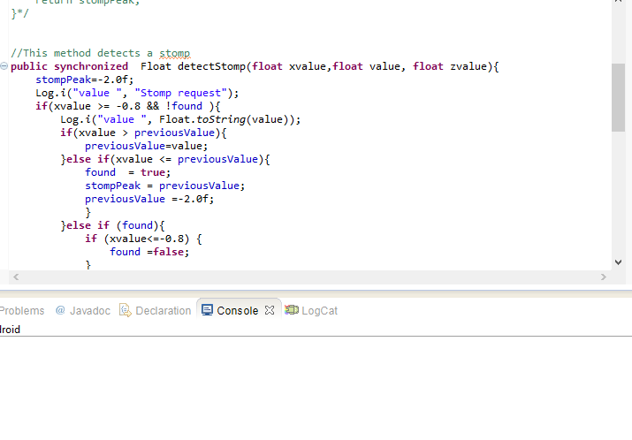

* Later Modified the Got2Run code and tried to trigger the jump activity.
* Performed the Jump activity.